**BEEE EVALUATION**

**CIRCUIT DIAGRAM:**

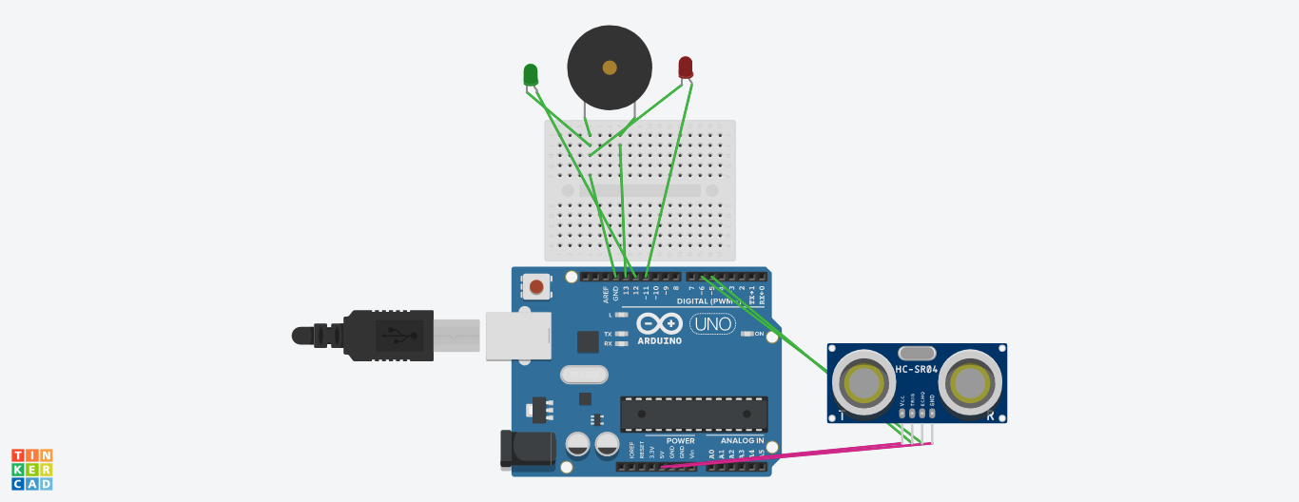

**THEORY:**

**CONCEPT USED:**

As soon as the gift box is opened, the buzzer gets the desired voltage and therefore it starts to produce sound and at the same time the LED’s get the desired voltage and starts blinking .

**LEARNING AND OBSERVATIONS:**

Following observations were recording during the experiment:

* The LED’s turn on when the input from the button is HIGH and turns off when it’s LOW.
* The button needs to be connected to the ground to give LOW input when the button is not pressed.

**PROBLEMS AND TROUBLESHOOTING:**

The problems faced while performing the experiment was that the problem compiled and uploaded to the board successfully but the LED’s didn’t glow.The problem was troubleshooted by replacing a connecting wire.

**PRECAUTIONS:**

The following precautions needs to be taken while performing an experiment;

* The connections of the USB in both the PC and ARDUINO UNO should be snug.
* The USB ports of the PC and the ARDUINO UNO should be in a working condition.
* The sketch should be logically and syntactically correct and germane to the experiment that needs to be performed.
* The correct serial port should be selected that is the one through which the ARDUINO UNO has been selected.
* Look for errors during compilation and upload of the executable to the ARDUINO UNO.
* Disconnect the digital 1 and 0 pins while uploading the program to the board.
* Do not open more than one instance of the ARDUINO IDE at a time.

**LEARNING OUTCOMES:**

The various learning outcomes has been made by performing the following experiment:

* Proper buzzer should be used, in order get its perfect sound.
* From this experiment, we got very deep information about the circuit, breadboard, LED, ARDUINO and programming.